  - Mind Maps

What is a Mind Map? A mind map is a visual tool used to organize information, ideas, or concepts. It usually starts with a central topic and expands outward with branches representing related subtopics, details, or tasks.
It helps with:
- Breaking down complex topics into smaller pieces.
- Improving memory and understanding (visual + structured).
- Planning, problem-solving, and brainstorming.
How to Approach Mind Map Creation
- Start with the central idea
- Place the main subject/problem/question in the center.
- Example: “API Testing”
- Branch out to major categories
- These are the main aspects of the topic.
- Example branches: Tools, Types of Testing, Challenges, Best Practices
- Add sub-branches
- Expand each major branch with details.
- Example: Under Tools → Postman, RestAssured, Playwright
- Use keywords, not sentences
- Keep it short and easy to scan.
- Add visuals (optional)
- Icons, colors, or symbols help recall faster.
- Iterate
- A mind map doesn’t need to be final in one go; you can keep refining.
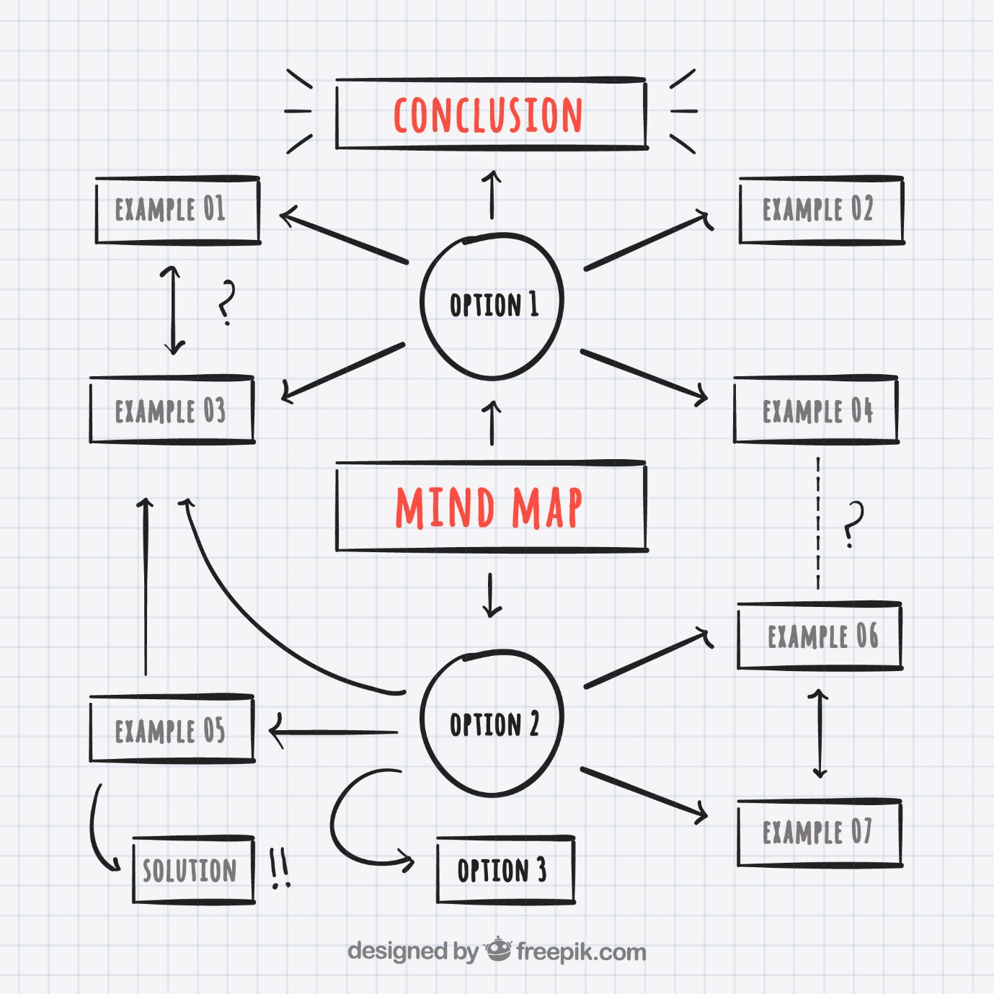
Figure 1 - Sample Mind Map

